**SALES DATA MySQL QUERIES**

**A ->Problem Statement:**

1. **Sales by Productline:**

**->** select productline ,sum(sales) from sales_data group by productline order by sum(sales) desc;

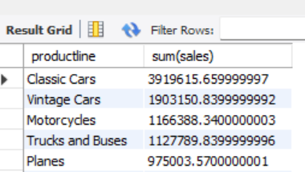

**2. Sales by Year:**

-> select year_id , sum(sales) from sales_data group by year_id order by sum(sales) desc;

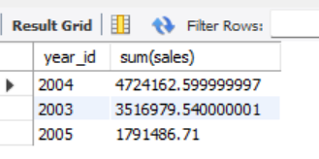

1. **Sales by Dealsize:**

**->** select dealsize , sum(sales) from sales_data group by dealsize order by sum(sales) desc ;

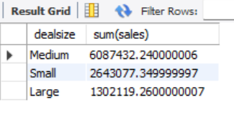

1. **Best Month For Sale Per Year:**

**->** select month_id , year_id, sum(sales) from sales_data where year_id = 2003 group by month_id , year_id order by sum(sales) desc limit 1 ;

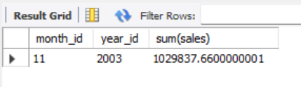

**->** select month_id , year_id, sum(sales) from sales_data where year_id = 2004 group by month_id , year_id order by sum(sales) desc limit 1 ;



**->** select month_id , year_id, sum(sales) from sales_data where year_id = 2005 group by month_id , year_id order by sum(sales) desc limit 1 ;

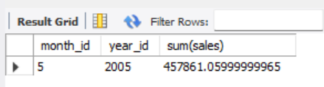

1. **Top 3 Customers On The Basis of Sales as per productline:**

**->** with

cte as

(select productline , customername, sum(sales) "total_sales" from sales_data group by productline , customername)

select * from (select *, row_number() over (partition by productline order by total_sales desc) "top3_customers" from cte) A

where top3_customers<= 3;

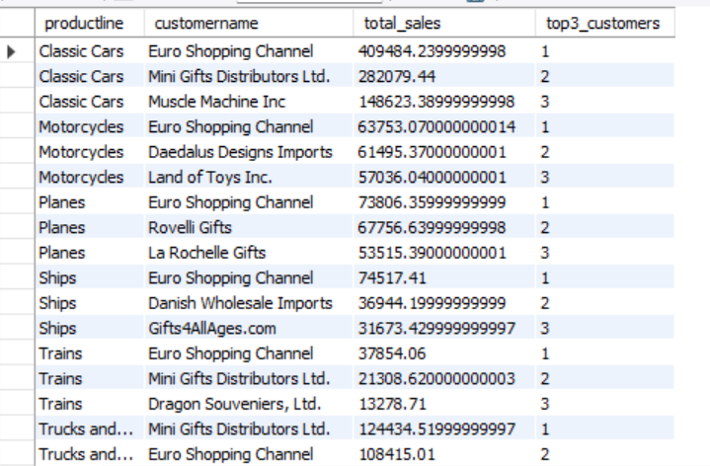

1. **Top 3 Customers on the Basis of Frequency according to Productline:**

**->**